**INNER JOIN:**

**SQL Query - 1**

**Send Feedback**

**Problem Statement:**  
Enlist all the employees ID's, names along with the Project allocated to them.

**Information about the table:**  
Table **Employee:** 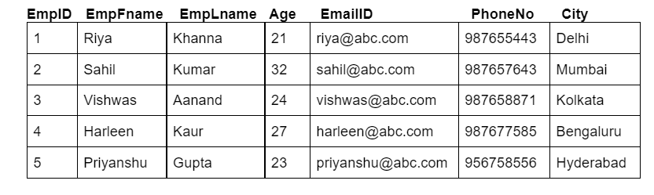  
Table **Project:** 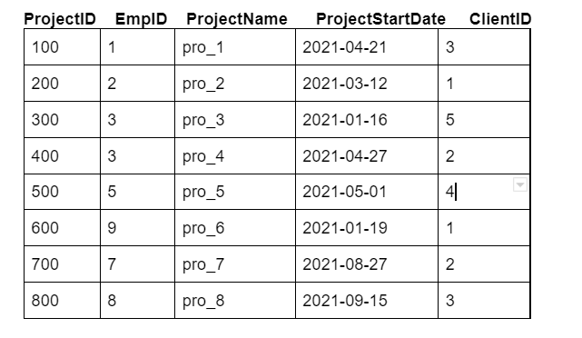  
Table **Client_d:** 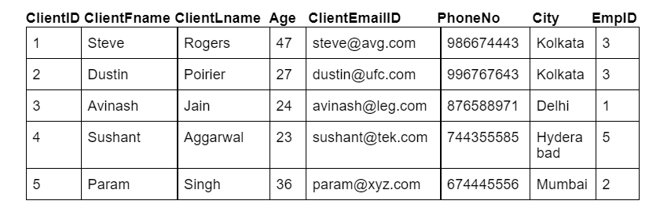

**Output Table Structure:**  


Note-1: Write keywords of syntax in uppercase alphabets.

Note-2: Use employee ID to link the two tables.

+-------+-----------+----------+-----------+-------------+

| EmpID | EmpFname | EmpLname | ProjectID | ProjectName |

+-------+-----------+----------+-----------+-------------+

| 1 | Riya | Khanna | 100 | pro_1 |

| 2 | Sahil | Kumar | 200 | pro_2 |

| 3 | Vishwas | Aanand | 300 | pro_3 |

| 3 | Vishwas | Aanand | 400 | pro_4 |

| 5 | Priyanshu | Gupta | 500 | pro_5 |

+-------+-----------+----------+-----------+-------------+

SELECT e.EmpID,e.EmpFname,e.EmpLname,p.ProjectID,p.ProjectName

from Employee as e

inner join

Project as p

on e.EmpID = p.EmpID;

**SQL Query - 2**

**Send Feedback**

**Problem Statement:**  
Fetch out all the employee ID’s and their contact detail who have been working from Delhi or have clients in Kolkata.

**Information about the table:**  
Table **Employee:**   
Table **Project:** 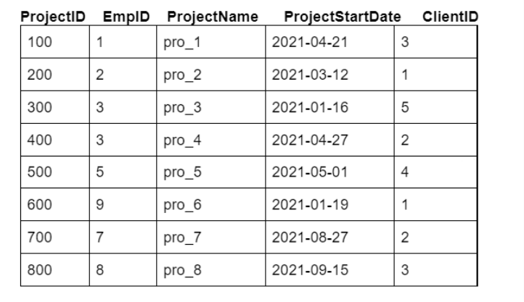  
Table **Client_d:** 

**Output Table Structure:**  


Note-1: Write keywords of syntax in uppercase alphabets.

Note-2: Use employee ID to link the two tables.

+-------+-----------------+-----------+-------------+-------------+

| EmpID | EmailID | PhoneNo | ClientFname | ClientLName |

+-------+-----------------+-----------+-------------+-------------+

| 3 | vishwas@abc.com | 987658871 | Steve | Rogers |

| 3 | vishwas@abc.com | 987658871 | Dustin | Poirier |

| 1 | riya@abc.com | 987655443 | Avinash | Jain |

+-------+-----------------+-----------+-------------+-------------+

SELECT e.EmpID,e.EmailID,e.PhoneNo,c.ClientFname,c.ClientLName

from Employee as e

inner join

Client_d as c

on e.EmpID = c.EmpID

where e.city = 'Delhi' or c.city = 'Kolkata';

**SQL Query - 3**

**Send Feedback**

**Problem Statement:**  
List out all the project names with corresponding client’s email id, for all the projects that were allocated after April 2021 and order them in descending order of the age of clients.

**Information about the table:**  
Table **Employee:**   
Table **Project:**   
Table **Client_d:** 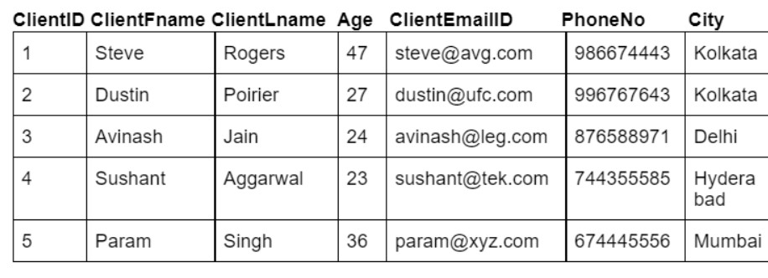

**Output Table Structure:**  


Note-1: Write keywords of syntax in uppercase alphabets.

Note-2: Use client ID to link the two tables.

+-------------+-----------------+

| ProjectName | ClientEmailID |

+-------------+-----------------+

| pro_7 | dustin@ufc.com |

| pro_8 | avinash@leg.com |

| pro_5 | sushant@tek.com |

+-------------+-----------------+

SELECT p.ProjectName,c.ClientEmailID

from Project as p

inner join

Client_d as c

on p.ClientID = c.ClientID

where p.ProjectStartDate >= '2021-05-01' order by c.age desc;

**SQL Query - 4**

**Send Feedback**

**Problem Statement:**  
Write an SQL query to inner join all the three table(Supplier, SP and Product) and print all the elements of the table. The tables should be joined in the same order as stated above.

**Information about the table:**  
Table **Product**:  
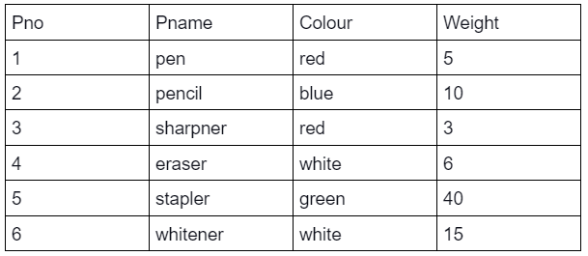  
Table **Supplier**:  
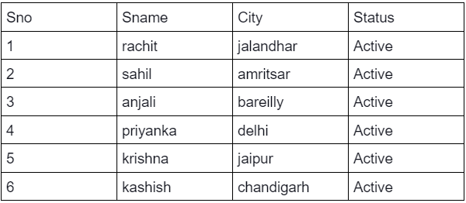  
Table **SP**:  
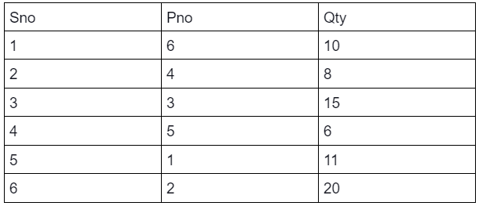

**Output Table Structure:**  


Note: Write keywords of syntax in uppercase alphabets. Also, the values should be sorted in ascending order of 'Pno'.

select S.Sno,S.Sname,S.City,S.Status,q.Sno,q.Pno,q.Qty,p.Pno,p.Pname,p.Colour,p.Weight

select S.*,q.*,p.*

from

Supplier S

inner join

SP q

on S.Sno = q.Sno

inner join

Product p

on q.Pno = p.Pno;

+------+----------+------------+--------+------+------+------+------+----------+--------+--------+

| Sno | Sname | City | Status | Sno | Pno | Qty | Pno | Pname | Colour | Weight |

+------+----------+------------+--------+------+------+------+------+----------+--------+--------+

| 5 | krishna | jaipur | active | 5 | 1 | 11 | 1 | pen | red | 5 |

| 6 | kashish | chandigarh | active | 6 | 2 | 20 | 2 | pencil | blue | 10 |

| 3 | anjali | bareilly | active | 3 | 3 | 15 | 3 | sharpner | red | 3 |

| 2 | sahil | amritsar | active | 2 | 4 | 8 | 4 | eraser | white | 6 |

| 4 | priyanka | delhi | active | 4 | 5 | 6 | 5 | stapler | green | 40 |

| 1 | rachit | jalandhar | active | 1 | 6 | 10 | 6 | whitener | white | 15 |

+------+----------+------------+--------+------+------+------+------+----------+--------+--------+

**SQL Query - 5**

**Send Feedback**

**Problem Statement:**  
Write a SQL query to find the name, colour and quantity of the product supplied by sahil. The tables (Supplier, SP and Product) should be joined in the same order as stated above.

**Information about the table:**  
Table **Product**:  
  
Table **Supplier**:  
  
Table **SP**:  


**Output Table Structure:**  


Note: Write keywords of syntax in uppercase alphabets.

+--------+--------+------+

| Pname | Colour | Qty |

+--------+--------+------+

| eraser | white | 8 |

+--------+--------+------+

select P.Pname,P.Colour,q.Qty

from

Supplier S

inner join

SP q

on S.Sno = q.Sno

inner join

Product p

on q.Pno = p.Pno

where S.Sname = 'sahil';

**SQL Query - 7**

**Send Feedback**

**Problem Statement:**  
Write a SQL query to find the max quantity (Qty) supplied by each status. The tables (Supplier, SP and Product) should be joined in the same order as stated in bracket.

Note: Name the column with max quantity as 'm'

**Information about the table:**  
Table **Product**:  
  
Table **Supplier**:  
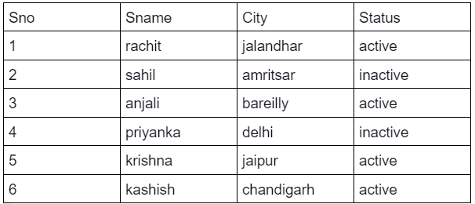  
Table **SP**:  


**Output Table Structure:**  


Note: Write keywords of syntax in uppercase alphabets.

+----------+------+

| Status | m |

+----------+------+

| active | 20 |

| inactive | 8 |

+----------+------+

select S.Status, max(q.Qty) as m

from

Supplier S

inner join

SP q

on S.Sno = q.Sno

inner join

Product p

on q.Pno = p.Pno

group by S.Status;

**SQL Query - 6**

**Send Feedback**

**Problem Statement:**  
Write an SQL query to find the number of products supplied by each colour.

**Information about the table:**  
Table **Product**:  
  
Table **Supplier**:  
  
Table **SP**:  


**Output Table Structure:**  


Note-1: Name the column containing number of products as nop.

Note-2: Write keywords of syntax in uppercase alphabets.

+--------+-----+

| Colour | nop |

+--------+-----+

| white | 2 |

| red | 2 |

| green | 1 |

| blue | 1 |

+--------+-----+

**select p.Colour,count(*) as nop**

**from**

**Product p**

**inner join**

**SP q**

**on p.Pno = q.Pno**

**group by p.Colour;**

**SQL Query - 8**

**Send Feedback**

**Problem Statement:**  
Write a SQL query to display the supplier name, product name and their active status in order of the quantity supplied. The tables (Supplier, SP and Product) should be joined in the same order as stated above.

**Information about the table:**  
Table **Product**:  
  
Table **Supplier**:  
  
Table **SP**:  


**Output Table Structure:**  


Note: Write keywords of syntax in uppercase alphabets.

+----------+----------+--------+

| Sname | Pname | Status |

+----------+----------+--------+

| priyanka | stapler | active |

| sahil | eraser | active |

| rachit | whitener | active |

| krishna | pen | active |

| anjali | sharpner | active |

| kashish | pencil | active |

+----------+----------+--------+

select S.Sname,p.Pname,S.Status

from

Supplier S

inner join

SP q

on S.Sno = q.Sno

inner join

Product p

on q.Pno = p.Pno

order by q.Qty

;

**SQL Query - 9**

**Send Feedback**

**Problem Statement:**  
Fetch out each project allocated to which employee.

**Information about the table:**  
Table **Employee:**   
Table **Project:**   
Table **Client_d:** 

**Output Table Structure:**  


Note-1: Write keywords of syntax in uppercase alphabets.

Note-2: Use employee ID to link the two tables.

+-----------+----------+-----------+-------------+

| EmpFname | EmpLname | ProjectID | ProjectName |

+-----------+----------+-----------+-------------+

| Riya | Khanna | 100 | pro_1 |

| Sahil | Kumar | 200 | pro_2 |

| Vishwas | Aanand | 400 | pro_4 |

| Vishwas | Aanand | 300 | pro_3 |

| Harleen | Kaur | NULL | NULL |

| Priyanshu | Gupta | 500 | pro_5 |

+-----------+----------+-----------+-------------+

SELECT e.EmpFname,e.EmpLname,p.ProjectID,p.ProjectName

from

Employee e

left join

Project p

on e.EmpID = p.EmpID;

**SQL Query - 10**

**Send Feedback**

**Problem Statement:**  
Write a SQL statement to make a report with buyer name, buyer city, product ID, purchased date, and amount in ascending order of the purchased date to find that either any of the existing customers have purchased any product or not.

**Information about the table:**  
Table **Buyer**:  
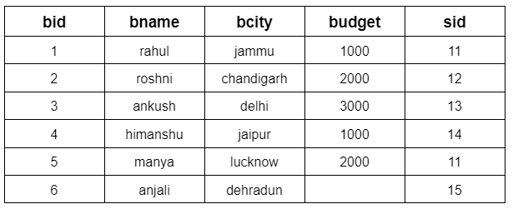  
Table **Seller**:  
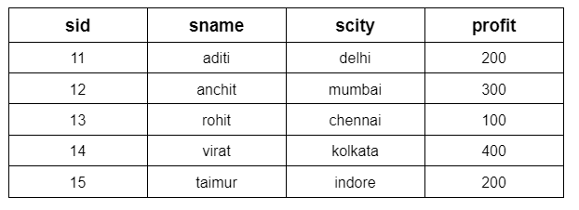  
Table **Product**:  
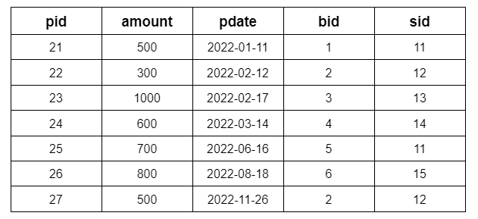

**Output Table Structure:**  


#### Note: Write keywords of syntax in uppercase alphabets.

+----------+------------+------+------------+--------+

| bname | bcity | pid | pdate | amount |

+----------+------------+------+------------+--------+

| rahul | jammu | 21 | 2022-01-11 | 500 |

| roshni | chandigarh | 22 | 2022-02-12 | 300 |

| ankush | delhi | 23 | 2022-02-17 | 1000 |

| himanshu | jaipur | 24 | 2022-03-14 | 600 |

| manya | lucknow | 25 | 2022-06-16 | 700 |

| anjali | dehradun | 26 | 2022-08-18 | 800 |

| roshni | chandigarh | 27 | 2022-11-26 | 500 |

+----------+------------+------+------------+--------+

SELECT b.bname,b.bcity,p.pid,p.pdate,p.amount

from

Product p

left join

Buyer b

on b.bid = p.bid;

**SQL Query - 11**

**Send Feedback**

**Problem Statement:**  
Write a SQL query to find those buyers whose budget is less than 3000 (or even NULL). Display the Buyer name, city, budget and Seller's name & city. The result should be in ascending order of buyers ID.

**Information about the table:**  
Table **Buyer**:  
  
Table **Seller**:  
  
Table **Product**:  


**Output Table Structure:**  


Note: Write keywords of syntax in uppercase alphabets.

+----------+------------+--------+--------+---------+

| bname | bcity | budget | sname | scity |

+----------+------------+--------+--------+---------+

| rahul | jammu | 1000 | aditi | delhi |

| roshni | chandigarh | 2000 | anchit | mumbai |

| himanshu | jaipur | 1000 | virat | kolkata |

| manya | lucknow | 2000 | aditi | delhi |

+----------+------------+--------+--------+---------+

SELECT b.bname,b.bcity,b.budget,s.sname,s.scity

from

Buyer b

left join

Seller s

on b.sid = s.sid

where b.budget<3000 or b.budget = NULL

order by b.bid;

**SQL Query - 12**

**Send Feedback**

**Problem Statement:**  
Write a SQL query to make a report, with buyer name, buyer city, product number, purchased date, amount, seller name and profit to find that either any of the existing buyer have purchased any product or not, by their seller.

**Information about the table:**  
Table **Buyer**:  
  
Table **Seller**:  
  
Table **Product**:  


**Output Table Structure:**  


Note: Write keywords of syntax in uppercase alphabets.

+----------+------------+------+------------+--------+--------+--------+

| bname | bcity | pid | pdate | amount | sname | profit |

+----------+------------+------+------------+--------+--------+--------+

| rahul | jammu | 21 | 2022-01-11 | 500 | aditi | 200 |

| roshni | chandigarh | 27 | 2022-11-26 | 500 | anchit | 300 |

| roshni | chandigarh | 22 | 2022-02-12 | 300 | anchit | 300 |

| ankush | delhi | 23 | 2022-02-17 | 1000 | rohit | 100 |

| himanshu | jaipur | 24 | 2022-03-14 | 600 | virat | 400 |

| manya | lucknow | 25 | 2022-06-16 | 700 | aditi | 200 |

| anjali | dehradun | 26 | 2022-08-18 | 800 | taimur | 200 |

+----------+------------+------+------------+--------+--------+--------+

select b.bname,b.bcity,p.pid,p.pdate,p.amount,s.sname,s.profit

from

Buyer b

left join

Product p

on b.bid = p.bid

left join

seller s

on s.sid = b.sid;

**SQL Query- 13**

**Send Feedback**

**Problem Statement:**  
List out all the projects along with the employee's name and their respective allocated email ID.

**Information about the table:**  
Table **Employee:**   
Table **Project:**   
Table **Client_d:** 

**Output Table Structure:**  


Note-1: Write keywords of syntax in uppercase alphabets.

Note-2: Use employee ID to link the two tables.

+-----------+-------------+-----------+----------+-------------------+

| ProjectID | ProjectName | EmpFname | EmpLname | EmailID |

+-----------+-------------+-----------+----------+-------------------+

| 100 | pro_1 | Riya | Khanna | riya@abc.com |

| 200 | pro_2 | Sahil | Kumar | sahil@abc.com |

| 300 | pro_3 | Vishwas | Aanand | vishwas@abc.com |

| 400 | pro_4 | Vishwas | Aanand | vishwas@abc.com |

| 500 | pro_5 | Priyanshu | Gupta | priyanshu@abc.com |

| 600 | pro_6 | NULL | NULL | NULL |

| 700 | pro_7 | NULL | NULL | NULL |

| 800 | pro_8 | NULL | NULL | NULL |

+-----------+-------------+-----------+----------+-------------------+

select p.ProjectID,p.ProjectName,e.EmpFname,e.EmpLname,e.EmailID

from

Employee e

right join

Project p

on e.EmpID = p.EmpID;

**SQL Query- 14**

**Send Feedback**

**Problem Statement:**  
List out all the client details email address, whose age is between 25 to 35, along with the projects assigned to them in ascending order of their age and project ID. Also, use c for client_d and p for project, as alias name of tables.

**Information about the table:**  
Table **Employee:**   
Table **Project:**   
Table **Client_d:** 

**Output Table Structure:**  


Note-1: Write keywords of syntax in uppercase alphabets.

Note-2: Use client ID to link the two tables.

+----------+-------------+-------------+----------------+-----------+-------------+

| ClientID | ClientFname | ClientLname | ClientEmailID | ProjectID | ProjectName |

+----------+-------------+-------------+----------------+-----------+-------------+

| 2 | Dustin | Poirier | dustin@ufc.com | 400 | pro_4 |

| 2 | Dustin | Poirier | dustin@ufc.com | 700 | pro_7 |

+----------+-------------+-------------+----------------+-----------+-------------+

Select c.ClientID,c.ClientFname,c.ClientLname,c.ClientEmailID,p.ProjectID,p.ProjectName

from

Project p

right join

Client_d c

on p.ClientID = c.ClientID

where c.age between 25 and 35

order by c.age,p.ProjectID;

**SQL Query - 15**

**Send Feedback**

**Problem Statement:**  
Write a SQL statement to make a list in ascending order for the sellers, display the buyer's name, city, budget, and seller's name & city.

**Information about the table:**  
Table **Buyer**:  
  
Table **Seller**:  
  
Table **Product**:  


**Output Table Structure:**  


Note: Write keywords of syntax in uppercase alphabets.

+----------+------------+--------+--------+---------+

| bname | bcity | budget | sname | scity |

+----------+------------+--------+--------+---------+

| manya | lucknow | 2000 | aditi | delhi |

| rahul | jammu | 1000 | aditi | delhi |

| roshni | chandigarh | 2000 | anchit | mumbai |

| ankush | delhi | 3000 | rohit | chennai |

| himanshu | jaipur | 1000 | virat | kolkata |

| anjali | dehradun | NULL | taimur | indore |

+----------+------------+--------+--------+---------+

select b.bname,b.bcity,b.budget,s.sname,s.scity

from

buyer b

right join

seller s

on b.sid = s.sid

order by s.sid;

**SQL query - 16**

**Send Feedback**

**Problem Statement:**  
Write a SQL query to list all sellers along with the buyer's name, buyer city, budget, product ID, purchased date, and purchased amount to find that either any of the existing sellers have sold any product or not.

**Information about the table:**  
Table **Buyer**:  
  
Table **Seller**:  
  
Table **Product**:  


**Output Table Structure:**  


#### Note: Write keywords of syntax in uppercase alphabets

select b.bname,b.bcity,b.budget,s.sname,p.pid,p.pdate,p.amount

from

Buyer b

right join

Seller s

on b.sid = s.sid

right join

Product p

on p.bid = b.bid;

+----------+------------+--------+--------+------+------------+--------+

| bname | bcity | budget | sname | pid | pdate | amount |

+----------+------------+--------+--------+------+------------+--------+

| rahul | jammu | 1000 | aditi | 21 | 2022-01-11 | 500 |

| roshni | chandigarh | 2000 | anchit | 22 | 2022-02-12 | 300 |

| ankush | delhi | 3000 | rohit | 23 | 2022-02-17 | 1000 |

| himanshu | jaipur | 1000 | virat | 24 | 2022-03-14 | 600 |

| manya | lucknow | 2000 | aditi | 25 | 2022-06-16 | 700 |

| anjali | dehradun | NULL | taimur | 26 | 2022-08-18 | 800 |

| roshni | chandigarh | 2000 | anchit | 27 | 2022-11-26 | 500 |

+----------+------------+--------+--------+------+------------+--------+

**SQL Query - 17**

**Send Feedback**

**Problem Statement:**  
List out all the combinations possible for the employee’s name and projects that can exist(NULL included).

**Information about the table:**  
Table **Employee:**   
Table **Project:**   
Table **Client_d:** 

**Output Table Structure:**  


#### Note: Write keywords of syntax in uppercase alphabets.

+-----------+----------+-----------+

| EmpFname | EmpLname | ProjectID |

+-----------+----------+-----------+

| Priyanshu | Gupta | 100 |

| Harleen | Kaur | 100 |

| Vishwas | Aanand | 100 |

| Sahil | Kumar | 100 |

| Riya | Khanna | 100 |

| Priyanshu | Gupta | 200 |

| Harleen | Kaur | 200 |

| Vishwas | Aanand | 200 |

| Sahil | Kumar | 200 |

| Riya | Khanna | 200 |

| Priyanshu | Gupta | 300 |

| Harleen | Kaur | 300 |

| Vishwas | Aanand | 300 |

| Sahil | Kumar | 300 |

| Riya | Khanna | 300 |

| Priyanshu | Gupta | 400 |

| Harleen | Kaur | 400 |

| Vishwas | Aanand | 400 |

| Sahil | Kumar | 400 |

| Riya | Khanna | 400 |

| Priyanshu | Gupta | 500 |

| Harleen | Kaur | 500 |

| Vishwas | Aanand | 500 |

| Sahil | Kumar | 500 |

| Riya | Khanna | 500 |

| Priyanshu | Gupta | 600 |

| Harleen | Kaur | 600 |

| Vishwas | Aanand | 600 |

| Sahil | Kumar | 600 |

| Riya | Khanna | 600 |

| Priyanshu | Gupta | 700 |

| Harleen | Kaur | 700 |

| Vishwas | Aanand | 700 |

| Sahil | Kumar | 700 |

| Riya | Khanna | 700 |

| Priyanshu | Gupta | 800 |

| Harleen | Kaur | 800 |

| Vishwas | Aanand | 800 |

| Sahil | Kumar | 800 |

| Riya | Khanna | 800 |

+-----------+----------+-----------+

select e.EmpFname,e.EmpLname,p.ProjectID

from

Employee e

cross join

Project p;

**SQL Query - 18**

**Send Feedback**

**Problem Statement:**  
Write a SQL query to make a list with the buyer’s name, buyer’s city, product id, purchased date and the amount for only those buyers in the table who must have a budget.

**Information about the table:**  
Table **Buyer**:  
  
Table **Seller**:  
  
Table **Product**:  


**Output Table Structure:**  


#### Note: Write keywords of syntax in uppercase alphabets.

+----------+------------+------+------------+--------+

| bname | bcity | pid | pdate | amount |

+----------+------------+------+------------+--------+

| rahul | jammu | 21 | 2022-01-11 | 500 |

| roshni | chandigarh | 27 | 2022-11-26 | 500 |

| roshni | chandigarh | 22 | 2022-02-12 | 300 |

| ankush | delhi | 23 | 2022-02-17 | 1000 |

| himanshu | jaipur | 24 | 2022-03-14 | 600 |

| manya | lucknow | 25 | 2022-06-16 | 700 |

+----------+------------+------+------------+--------+

SELECT b.bname,b.bcity,p.pid,p.pdate,p.amount

from Buyer b

left join

Product p

on b.bid = p.bid

where b.budget is not null

union

SELECT b.bname,b.bcity,p.pid,p.pdate,p.amount

from Buyer b

right join

Product p

on b.bid = p.bid

where b.budget is not null;